Title:
UIDAI Data Hackathon 2026
Aadhaar Enrolment and Biometric Analytics – West Bengal
Subtitle:
A Data-Driven Study on Demographic Trends, Geographic Distribution, and Operational Insights
Submitted by:
Team Name:
Team DataCore
Team Members (3):
- Subhankar Sarkar
- Payal Kangsabanik
- Arpita Chakraborty

Hackathon Organized by:
Unique Identification Authority of India (UIDAI)
Year: 2026

Declaration
We hereby declare that this project titled “Aadhaar Enrolment and Biometric Analytics – West Bengal” was completed by a team of three members as part of the UIDAI Data Hackathon 2026. The work presented in this report is original and based on the datasets provided by UIDAI. All analysis, interpretations, and conclusions are derived solely for academic and analytical purposes.

Acknowledgement
We would like to express our sincere gratitude to UIDAI for organizing the Data Hackathon 2026 and for providing access to high-quality Aadhaar enrolment and biometric datasets. This opportunity allowed us to apply data analytics concepts to real-world governance and public service challenges. We also thank our mentors, peers, and organizers for their continuous guidance and support throughout the hackathon.

Table of Contents
- Introduction
- Problem Statement
- Team Contribution Overview
- Dataset Description
- Methodology
- Tools and Technologies Used
- Data Analysis and Visualisation
  - District-wise Analysis
  - Monthly Trend Analysis
  - Age-wise Enrolment Analysis
  - Pincode-level Analysis
  - Pincode–District Mapping Anomalies
- Key Insights
- Impact and Applicability
- Conclusion

1. Introduction
Aadhaar is India’s foundational digital identity system and plays a critical role in enabling access to government services, welfare schemes, education, employment, and financial inclusion. Large volumes of enrolment and biometric update data are generated daily through Aadhaar operations. Analyzing this data can provide valuable insights into demographic behavior, service demand, regional disparities, and data quality issues.
This project focuses on the analytical study of Aadhaar enrolment and biometric update data for the state of West Bengal using datasets provided by UIDAI during the Data Hackathon 2026.

2. Problem Statement and Approach
Problem Statement: Unlocking Societal Trends in Aadhaar Enrolment and Updates
The UIDAI Data Hackathon 2026 focuses on identifying meaningful patterns, trends, anomalies, or predictive indicators from Aadhaar enrolment and update data. Participants are expected to translate these findings into clear insights or solution frameworks that can support informed decision-making and system improvements.
The objective is to leverage Aadhaar enrolment and biometric update datasets to understand societal behavior, demographic trends, regional disparities, and operational challenges, and to provide data-driven recommendations that enhance efficiency, accuracy, and outreach of Aadhaar services.
Our Analytical Approach
To address the above problem statement, our team adopted a structured, data-driven analytical approach:
- Exploratory analysis of Aadhaar enrolment and biometric update data
- Demographic segmentation by age groups
- Geographic analysis at district and pincode levels
- Time-series analysis to identify trends and seasonal patterns
- Detection of anomalies such as pincode–district mapping inconsistencies
This approach ensures alignment with UIDAI’s expectations and translates raw Aadhaar data into actionable societal and administrative insights.

3. Team Contribution Overview
This project was completed collaboratively by a team of three members:
- Member 1: Data cleaning, preprocessing, aggregation logic
- Member 2: Exploratory data analysis and visualization
- Member 3: Insight interpretation, documentation, and reporting
All members contributed equally to analysis, validation, and report preparation.

4. Dataset Description
Multiple UIDAI datasets were used to ensure comprehensive analysis:
- District-level Aadhaar enrolment data
- Pincode-level Aadhaar enrolment data
- Monthly enrolment trend datasets
- Biometric update datasets (district, pincode, and month level)
- Pincode–district mapping files
Key Attributes:
- State, District, Pincode
- Month / Date
- Age Groups (5–17, 17+)
- Total Enrolment and Biometric Update Counts
All datasets focus on Aadhaar activity within West Bengal across multiple months and years.

5. Methodology
5.1 Data Preprocessing
- Removed null and duplicate records
- Standardized district and state names
- Verified numeric enrolment fields
- Sorted data chronologically
5.2 Data Aggregation
- Aggregated data at district, pincode, and monthly levels
- Created total enrolment metrics
- Segmented enrolments by age groups
5.3 Analytical Approach
- Temporal analysis for monthly trends
- Geographic analysis for district and pincode comparisons
- Demographic analysis by age groups
- Anomaly detection for pincode–district inconsistencies

6. Tools and Technologies Used
- Python: Pandas, NumPy (data cleaning and analysis)
- Excel: Exploratory analysis and validation
- Power BI: Interactive dashboards and visual insights
- Jupyter Notebook: Reproducible analytics workflow

7. Data Analysis and Visualisation
  - Aadhaar Enrolment Analysis (Primary Focus)
7.1.1 Problem Statement and Approach
Aadhaar serves as a foundational digital identity system in India, enabling access to government services, welfare schemes, and financial inclusion. This project aims to analyze Aadhaar enrolment data for West Bengal to understand demographic behavior, geographic disparities, and temporal trends. The analytical approach focuses on exploratory data analysis using district-level, pincode-level, and time-series datasets to uncover actionable insights that can assist UIDAI in improving operational efficiency and outreach strategies.
    - Datasets Used
The analysis uses multiple UIDAI Aadhaar datasets, including:
• west_bengal_district_level_all.csv
• west_bengal_pincode_level.csv
• west_bengal_cleaned_data.csv
• wb_month_enroll_trend.csv
Key Columns:
•district_clean
• pincode
• date
• age_0_5, age_5_17, age_18_greater
• total_enroll
    - Methodology
Data Cleaning:
• Removal of null and duplicate records
• Standardization of district names
Preprocessing:
• Aggregation at district and pincode levels
• Feature engineering for age-group totals
Tools Used:
• Python (Pandas, NumPy)
• Power BI for visual analytics
• Excel for exploratory checks

    - Data Analysis & Visualization
Age-wise Aadhaar Enrollment by District
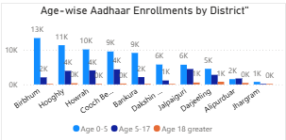
Observation: Certain districts like Murshidabad, Nadia, and Birbhum show significantly higher enrollments, driven mainly by the 0–5 age group.
Insight
- Districts like Birbhum, Hooghly, Howrah, Cooch Behar show the highest total enrollments.
- The 0–5 age group dominates in every major district.
- Adult enrollments (18+) are consistently low across all districts.
Impact
- Indicates that new Aadhaar growth is driven by children, not adults.
- Helps UIDAI focus child enrollment drives in high-growth districts.
- Supports school & hospital-based registration programs.
Contribution of Age Groups by District
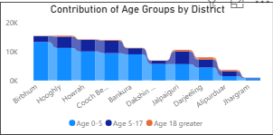
Observation: Across most districts, child enrollment dominates total Aadhaar registrations.
Insight
- Child enrollments form the base layer of total enrollment in all districts.
- Teen enrollments (5–17) add moderate volume.
- Adult enrollments are a minor contributor everywhere.
Impact
- Confirms Aadhaar adult coverage saturation.
- Suggests shifting outreach strategy from adults to newborn registrations.
- Enables resource reallocation toward pediatric Aadhaar centers.

Age Group Share Across All Pin codes
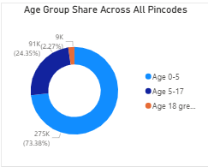Observation: Over 70% of Aadhaar enrollments come from the 0–5 age group, indicating strong child-focused adoption.
Insight
- 0–5 age group ≈ 73% of total enrollments.
- 5–17 age group ≈ 24%.
- 18+ age group < 3%.
Impact
- Strong evidence that Aadhaar growth is child-driven.
- Supports policy prioritization for early-life digital identity.
- Helps justify investment in maternal & child health center enrollment booths.
Top 10 Enrollment Districts
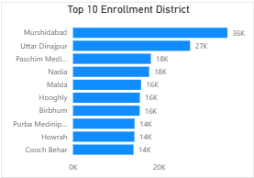
Observation: A small number of districts contribute disproportionately to overall enrollment volume.
Insight
- Murshidabad, Uttar Dinajpur, Nadia, Hooghly dominate enrollments.
- A small number of districts contribute a disproportionate share of total volume.
Impact
- Identifies enrollment hotspots for infrastructure expansion.
- Helps prioritize staffing, equipment, and outreach budgets.
- Enables performance benchmarking for low-performing districts.

Scatter Plot – Age Mix Pattern
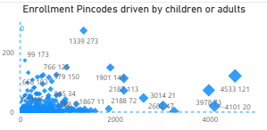
Observation: High-enrollment pin codes are largely child-driven, while adult-heavy regions are rare.
Insight
- High-enrollment pin codes cluster far right on X-axis (high child enrollments).
- Very few large bubbles appear high on Y-axis (adult-heavy zones).
- Balanced child–adult high-volume pin codes are rare.
Impact
- Confirms that high-volume locations are child-driven.
- Helps identify industrial or migrant zones (adult-heavy pin codes).
- Supports targeted adult re-enrollment or update drives in specific areas.
KPI Summary
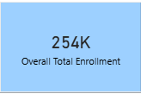
Observation: The total Aadhaar enrollment across analyzed datasets is approximately 254,000, confirming strong regional demand.
Insight
- Total Aadhaar enrollments ≈ 254,000 across all analyzed data.
- Indicates strong regional enrollment activity.
Impact
- Provides a single executive metric for leadership dashboards.
- Useful for policy reporting and progress tracking.
- Acts as a baseline for future forecasting and benchmarking.
Time-Series Enrollment Trend
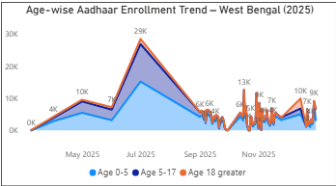
Observation: A sharp enrollment spike is observed in mid-2025, likely due to a major government enrollment drive.
Insight
- A massive enrollment spike (~29K) occurs around June–July 2025.
- Growth is mainly driven by the 0–5 age group.
- Post-spike, enrollments stabilize at a lower baseline.
- Adult enrollments remain flat throughout.
Impact
- Indicates the effect of a major government enrollment campaign.
- Helps assess campaign success and duration.
- Supports seasonal planning for future drives.
- Suggests timing future outreach around high-response months.

- Key Insights Summary
- Aadhaar enrollment is heavily skewed toward children (0–5 age group)
- A limited number of districts and pincodes dominate total enrollments
- Adult enrollments remain comparatively low and stable
- A major enrollment surge occurred in mid-2025

    - Impact and Applicability
Administrative Impact:
• Supports targeted resource allocation
• Helps identify enrollment hotspots
• Improves outreach strategy
Social Impact:
• Encourages early-age Aadhaar adoption
• Enhances access to government benefits
• Supports inclusive digital identity coverage

7.2 Demographic Analysis
7.2.1 Problem Statement
Aadhaar plays a critical role in enabling access to government services, financial inclusion, and digital identity in India. Understanding enrolment and update patterns can help identify operational gaps, regional disparities, and demographic trends.
The objective of this project is to analyze Aadhaar demographic enrolment data to uncover:
- Regional variations in enrolment demand
- Age-wise enrolment behavior
- Seasonal trends
- Data anomalies at pincode and district levels
The insights aim to support UIDAI in improving service delivery efficiency, data quality, and policy planning.
7.2.2 Dataset Description
This analysis uses datasets officially provided by UIDAI for the Data Hackathon 2026.
Key Attributes Used:
- State and District
- Pincode
- Date / Month
- Age Group (5–17, 17+)
- Total Enrolment Count
The dataset spans multiple years and enables analysis at state, district, month, and pincode granularity.

7.2.3 Methodology
The analysis was conducted using a structured data analytics workflow:
Data Preprocessing
- Removal of null and duplicate records
- Standardization of state and district names
- Aggregation of enrolment data at district, month, and pincode levels
Feature Engineering
- Creation of total enrolment metrics
- Age-wise enrolment segmentation
- Identification of pincode–district conflicts
Tools and Technologies
- Python (Pandas, NumPy) for data processing
- Excel for visualization and exploratory analysis
7.2.4. Data Analysis & Visualisation
District-wise Aadhaar Enrolment Distribution
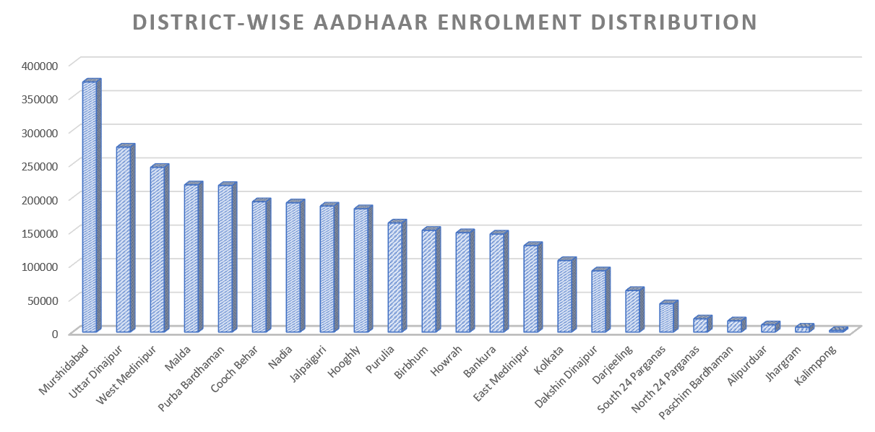
Observation:
A small number of districts contribute a disproportionately high share of Aadhaar enrolments in West Bengal.
Impact:
This indicates uneven service demand and suggests the need for targeted infrastructure and staffing in high-burden districts.
Monthly Aadhaar Enrolment Trends
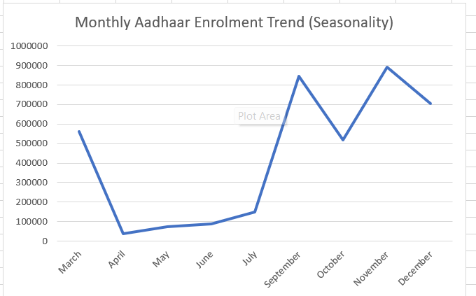Observation:
Monthly enrolment trends remain relatively stable with mild seasonal variations.
Use Case:
These trends can help UIDAI forecast enrolment demand and optimize operational planning during peak periods.
Age-wise Aadhaar Enrolment Analysis
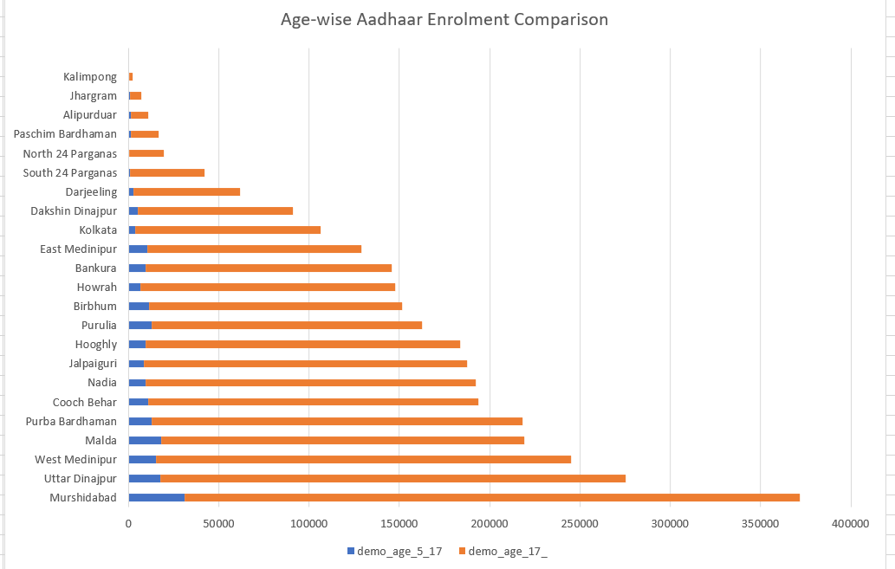Observation:
The 17+ age group accounts for the majority of Aadhaar enrolments compared to the 5–17 age group.
Insight:
This suggests that Aadhaar adoption increases significantly in adulthood due to employment, education, and financial service requirements.
Pincode–District Mapping Conflicts (Anomaly Detection)
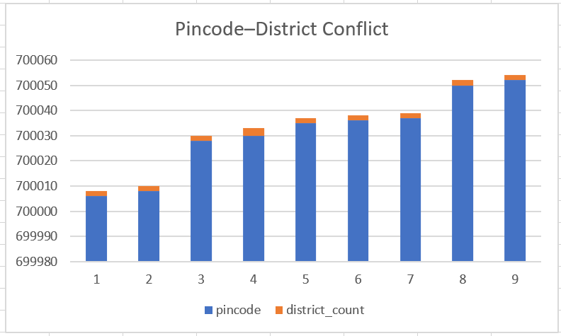
Observation:
Several pincodes are associated with multiple districts, indicating potential mapping inconsistencies.
Impact:
Such anomalies can lead to data inaccuracies and service delivery challenges.
Recommendation:
Regular validation of pincode–district mappings can improve Aadhaar data quality and operational efficiency.
Pin code-level Aadhaar Enrolment Analysis
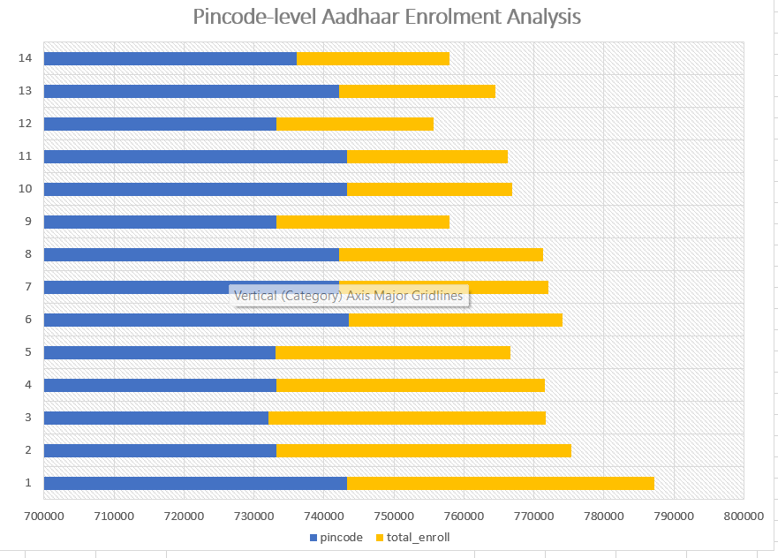
Observation:
Aadhaar enrolment is concentrated in a limited number of pincodes, while many pincodes show lower enrolment volumes.
Insight:
High-enrolment pincodes reflect localized demand, primarily driven by the 17+ age group.
Impact:
This helps UIDAI identify enrolment hotspots and plan targeted infrastructure deployment.
7.2.5 Key Insights Summary
- Aadhaar enrolment demand is unevenly distributed across districts
- Adult enrolment dominates Aadhaar registration
- Monthly enrolment patterns show predictable stability
- Pincode–district conflicts reveal data quality improvement opportunities
7.2.6. Impact and Applicability
Administrative Impact
- Improved resource allocation
- Identification of operational hotspots
- Enhanced data accuracy
Social Impact
- Supports inclusive Aadhaar coverage
- Enables better access to welfare schemes
- Encourages early-age enrolment awareness
7.3 Biometric Enrolment and Update Analysis
7.3.1.Problem Statement:
Aadhaar is a key digital identity system that enables access to government services, welfare schemes, and financial inclusion across India. However, enrolment and biometric update data generated through Aadhaar operations are often underutilized for understanding demand patterns, regional disparities, and operational challenges.
This project analyses Aadhaar enrolment and biometric update data for West Bengal to identify temporal trends, geographic concentration, demographic differences, and data anomalies. The objective is to derive actionable insights that can support UIDAI in improving resource planning, service efficiency, and data quality through evidence-based decision-making.

7.3.2. Dataset Description:
This analysis uses multiple Aadhaar enrolment and biometric update datasets provided by UIDAI as part of the hackathon data resources. The datasets collectively enable analysis across different geographic granularities and time periods for the state of West Bengal.
Datasets Used
- Monthly Biometric Enrolment Dataset
  - File: df_west_bengal_month_bio_level.xlsx
  - Granularity: Month-level
  - Purpose: Analyze temporal trends, seasonality, and demand stability
- District-wise Biometric Dataset
  - File: df_west_bengal_dist_bio_level.xlsx
  - Granularity: District-level
  - Purpose: Identify high-burden districts and regional disparities
- Pincode-wise Biometric Dataset
  - File: df_west_bengal_pincode_bio_level.xlsx
  - Granularity: Pincode-level
  - Purpose: Detect enrolment hotspots and localized service concentration
- Pincode–District Mapping Dataset
  - File: pin_district_bio_map_wb.xlsx
  - Purpose: Validate geographic consistency and detect mapping anomalies
- Flagged Dominant Pincode Dataset
  - File: flagged_pincode_dominant_west_bengal_bio.xlsx
  - Purpose: Identify pincodes disproportionately contributing to biometric updates
All datasets focus on Aadhaar enrolment and biometric update activity within West Bengal and span multiple months, enabling both trend and distribution analysis.
7.3.3. Methodology:
The analysis was conducted using a structured and systematic data analytics workflow to ensure accuracy, reproducibility, and interpretability of insights.
3.1 Data Preprocessing
- Removed missing and duplicate records
- Standardized column names and categorical values
- Verified numeric enrolment and biometric fields
- Sorted data chronologically for temporal analysis
3.2 Data Aggregation and Transformation
- Aggregated biometric data at:
  - Monthly level for trend analysis
  - District level for regional comparison
  - Pincode level for hotspot detection
- Created derived metrics:
  - Total enrolments across age groups
  - Percentage contribution by district and pincode
- Mapped pincodes to districts to identify inconsistencies
3.3 Analytical Approach
- Temporal Analysis: Monthly trends to identify stability, seasonality, and peaks
- Geographic Analysis: District and pincode comparisons to assess demand distribution
- Demographic Segmentation: Age-group comparison (5–17 and 17+)
- Anomaly Detection: Identification of spikes, dominant pincodes, and mapping conflicts
3.4 Tools and Technologies
- Excel: Data aggregation, visualization, and exploratory analysis
- Python (Jupyter Notebook): Data cleaning, validation, and reproducible analysis
7.3.4. Data Analysis & Visualisation:
4.1 Monthly Aadhaar Enrolment and Biometric Update Trends:
Overview
This section examines monthly Aadhaar enrolment and biometric update trends in West Bengal to identify demand patterns, peak periods, and consistency over time. The insights support improved operational planning, staffing, and infrastructure deployment at Aadhaar enrolment centers.
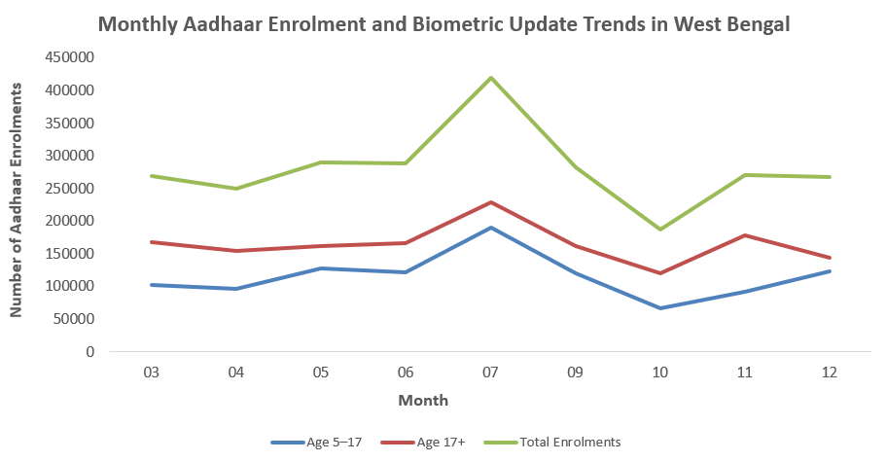

Insight 1: Stable Monthly Enrolment Pattern
Observation:
Aadhaar enrolment and biometric update volumes remain relatively stable across most months, without major fluctuations.
Interpretation:
This indicates that biometric updates are a continuous and routine requirement rather than a sporadic activity.
Impact:
Stable demand allows UIDAI to plan long-term infrastructure and staffing efficiently, ensuring uninterrupted service delivery.
Insight 2: Mid-Year Peak in Enrolments
Observation:
A clear peak in enrolment and biometric updates is observed during the mid-year period, particularly around July.
Interpretation:
This surge likely reflects increased Aadhaar usage driven by institutional needs such as education, employment, or government schemes.
Operational Use Case:
Identifying peak periods enables proactive scaling of enrolment center capacity to manage higher citizen footfall.
Insight 3: Age Group–Wise Enrolment Differences
Observation:
Across all months, the 17+ age group consistently records higher enrolment volumes than the 5–17 age group.
Interpretation:
This reflects greater Aadhaar dependency among adults for financial, employment, and welfare-related services.
Policy Insight:
Promoting early-age enrolment and timely biometric updates can improve coverage and reduce future update backlogs.
Insight 4: Post-Peak Decline in Demand
Observation:
Following the mid-year peak, enrolment volumes decline before stabilizing in later months.
Interpretation:
This suggests event-driven demand during peak periods, followed by normalization once requirements are met.
Administrative Value:
Understanding this pattern helps optimize resource allocation after peak demand subsides.
Insight 5: Long-Term Predictability of Biometric Demand
Observation:
Despite short-term variations, the overall enrolment trend remains consistent across months.
Interpretation:
This highlights the ongoing relevance of Aadhaar enrolment and biometric updates throughout the year.
Impact:
Predictable demand supports the need for stable, well-distributed Aadhaar infrastructure rather than ad-hoc arrangements.
  - Pincode–District Mapping Consistency Analysis
Overview
This section examines the consistency of pincode-to-district mappings in Aadhaar biometric data to identify potential geographic anomalies and data quality issues that may impact enrolment reporting and service delivery.

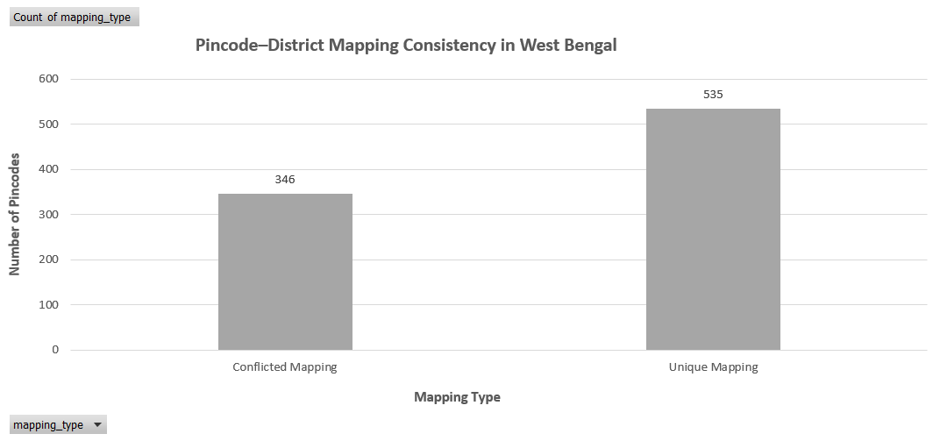

Insight 1: Majority of Pincodes Have Unique District Mapping
Observation:
The visualization shows that 535 out of 881 pincodes are mapped uniquely to a single district.
Interpretation:
This indicates that Aadhaar pincode–district data is largely consistent and geographically reliable across West Bengal.
Impact:
High mapping accuracy supports dependable district-level enrolment analysis and informed administrative planning.
Insight 2: Presence of Conflicted Pincode Mappings
Observation:
A total of 346 pincodes are associated with more than one district.
Interpretation:
These conflicted mappings highlight localized inconsistencies in geographic attribution, potentially arising from administrative overlaps or data recording issues.
Impact:
Such inconsistencies can distort district-wise enrolment statistics and affect equitable resource allocation.
Insight 3: Mapping Conflicts Are Localized, Not System-Wide
Observation:
Conflicted mappings account for a smaller proportion of total pincodes compared to unique mappings.
Interpretation:
This suggests that data quality issues are limited to specific pincodes rather than representing a systemic problem.
Recommendation:
Targeted verification and correction of conflicted pincodes can significantly improve data accuracy with minimal operational effort.
Insight 4: Importance for Operational and Policy Planning
Observation:
Incorrect pincode–district associations may misrepresent enrolment demand in affected districts.
Interpretation:
This can lead to over- or under-estimation of service load at enrolment centers.
Administrative Value:
Ensuring accurate pincode mapping enhances infrastructure planning, staffing decisions, and overall service efficiency.
  - District-wise Aadhaar Enrolment Analysis
Overview
This section analyzes district-wise Aadhaar enrolment and biometric update volumes in West Bengal to identify regional variations in service demand and assess the distribution of enrolment activity across districts.

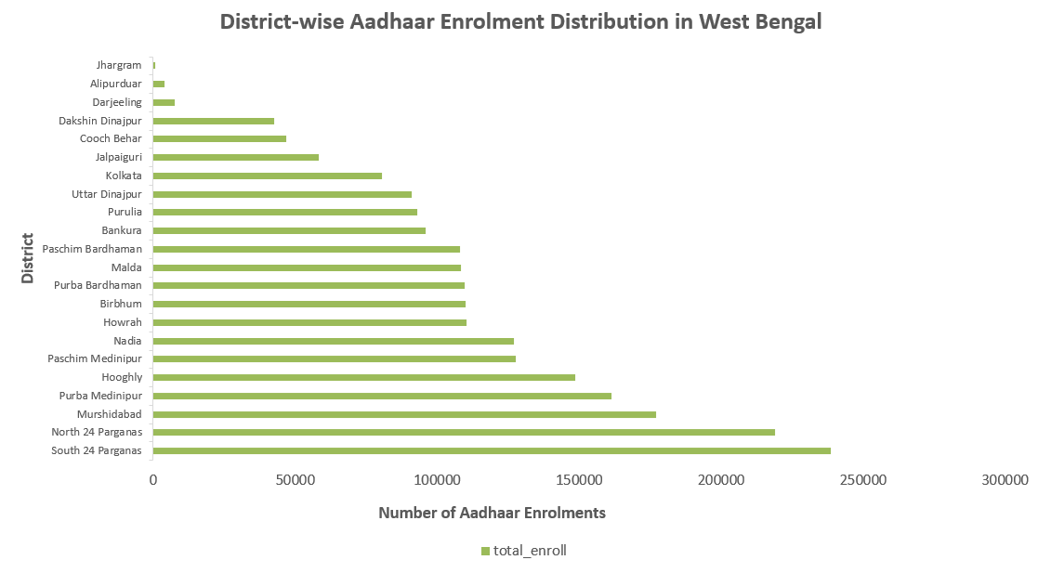
Insight 1: Enrolment Demand Is Concentrated in a Few Districts
Observation:
Districts such as South 24 Parganas, Murshidabad, and Hooghly record significantly higher Aadhaar enrolment volumes compared to other districts.
Interpretation:
These districts likely represent densely populated or highly urbanized regions with greater reliance on Aadhaar-enabled services.
Impact:
Such districts act as enrolment demand hubs and require sustained infrastructure capacity and staffing support.

Insight 2: Moderate Enrolment Across Mid-Tier Districts
Observation:
Districts like Nadia, Birbhum, Malda, and Bankura show moderate and comparable enrolment volumes.
Interpretation:
This suggests a relatively balanced demand in these regions without extreme pressure on enrolment infrastructure.
Operational Value:
Standardized resource allocation may be sufficient for these districts, with periodic monitoring for demand changes.

Insight 3: Low Enrolment in Smaller or Remote Districts
Observation:
Districts such as Alipurduar and Dakshin Dinajpur record comparatively lower enrolment volumes.
Interpretation:
Lower enrolment may be influenced by smaller populations, geographic constraints, or reduced accessibility to enrolment centers.
Policy Insight:
Mobile enrolment units and targeted awareness programs can help improve Aadhaar coverage in these regions.

  - Pincode-wise Aadhaar Enrolment Distribution
Overview
This section analyzes Aadhaar enrolment and biometric update distribution at the pincode level in West Bengal. The objective is to identify enrolment concentration patterns and detect pincodes with unusually high or low Aadhaar activity.
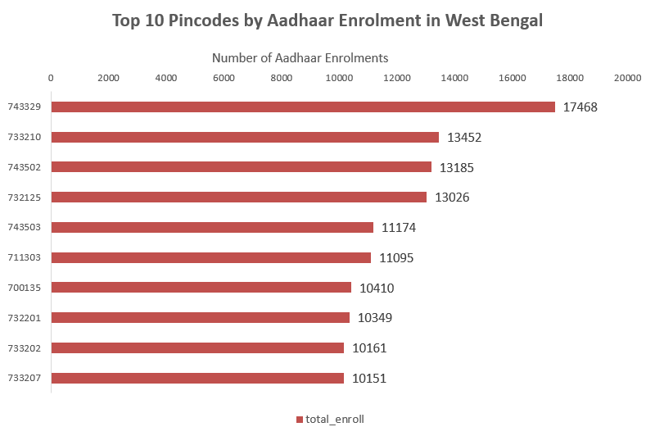Insight 1: Aadhaar Enrolment Is Highly Concentrated in Specific Pincodes
Observation:
The top pincode (743329) records the highest Aadhaar enrolments, significantly exceeding other pincodes in the top 10.
Interpretation:
This indicates localized enrolment demand hotspots, likely driven by higher population density, urbanization, or the presence of major Aadhaar enrolment centers.
Impact:
These high-demand pincodes require sustained staffing, infrastructure, and system availability to avoid service delays.

Insight 2: Gradual Decline Indicates Uneven Pincode-Level Demand
Observation:
After the top 2–3 pincodes, enrolment numbers decline steadily across the remaining pincodes.
Interpretation:
Aadhaar enrolment demand is not evenly distributed at the pincode level, suggesting disparities in access, awareness, or population distribution.
Operational Value:
Targeted interventions such as mobile enrolment units or awareness campaigns can help improve coverage in lower-demand pincodes.

Insight 3: Opportunity for Micro-Level Resource Optimization
Observation:
All top 10 pincodes still maintain substantial enrolment volumes, indicating consistent but varying demand.
Interpretation:
Micro-level (pincode-wise) analysis enables more precise allocation of enrolment resources rather than district-wide uniform planning.
Policy Insight:
Data-driven pincode prioritization can enhance service efficiency while reducing congestion at high-volume locations.

  - Pincode–District Dominance and Mapping Anomalies
Overview
This section analyzes pincode-level dominance patterns in West Bengal using flagged Aadhaar biometric data. The objective is to classify pincodes based on dominant enrolment behavior and to highlight variations across regions. Such analysis helps in understanding enrolment distribution characteristics and supports better data monitoring and administrative planning for Aadhaar services.

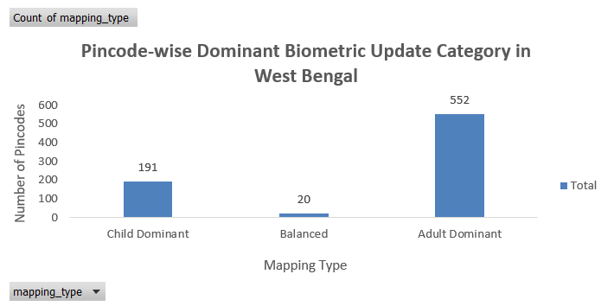

Insight 1: Adult-Dominant Pincodes Are the Majority
Observation:
Most pincodes fall under the Adult Dominant category.
Interpretation:
This indicates that Aadhaar biometric updates are primarily driven by the 17+ population, likely due to employment, banking, welfare schemes, and identity verification needs.
Impact:
Enrolment centers should prioritize adult biometric update capacity to handle sustained demand.

Insight 2: Child-Dominant Pincodes Form a Smaller but Significant Segment
Observation:
A smaller proportion of pincodes are classified as Child Dominant.
Interpretation:
This reflects areas with higher child enrolment or update activity, possibly linked to school admissions or age-based biometric updates.
Operational Value:
Targeted child enrolment drives can be planned in these regions to ensure timely Aadhaar updates.

Insight 3: Limited Balanced Pincodes Indicate Uneven Age Distribution
Observation:
Very few pincodes show Balanced biometric activity across age groups.
Interpretation:
Most regions exhibit a clear skew toward either adult or child updates rather than uniform demand.
Policy Insight:
Age-specific enrolment strategies may be more effective than one-size-fits-all approaches.
8. Key Insights
- Aadhaar enrolment demand is uneven across districts and pincodes
- Adult enrolments dominate overall Aadhaar activity
- Monthly trends are predictable with seasonal peaks
- Data anomalies exist at the pincode–district mapping level
9. Impact and Applicability
Administrative Impact
- Improved resource allocation
- Identification of operational hotspots
- Better infrastructure planning
Social Impact
- Supports inclusive Aadhaar coverage
- Enhances access to welfare schemes
- Encourages early-age enrolment awareness

Conclusion
This consolidated analysis demonstrates how Aadhaar enrolment and biometric data can be effectively used to generate actionable insights for governance and public service delivery. By prioritizing enrolment trends, followed by demographic and biometric analysis, the project aligns closely with the UIDAI Data Hackathon 2026 problem statement of unlocking societal trends in Aadhaar enrolment and updates.
The findings highlight key demographic patterns, geographic concentration of demand, seasonal enrolment behavior, and data quality challenges such as pincode–district inconsistencies. These insights can support UIDAI in data-driven decision-making, optimized resource allocation, improved service delivery, and informed policy formulation.

